ctFIRE V1.0 Users Manual

Main Developers:  Yuming Liu, Jeremy Bredfeldt

February 13, 2013

1 Introduction 1

2 GUI control panel 2

3 Tutorial 4

3.1 Step 1: open images 4

3.2 Step 2: set input and output parameters: 6

3.3 Step 3: run 7

3.4 Step 4: check the results: 9

3.5 Step 5: post-processing 10

3.6 Step 6: Reset 13

# Introduction

The purpose of this standalone MATLAB package is to allow users to automatically extract and quantify the alignment of collagen fibers in an image. The program reads in image files, extracts the individual collagen fibers via ctFIRE ( curvelet transform plus FIRE algorithm) , which is an approach combining the advantage of the fast discrete curvelet transform[1] for denoising the image and enhancing the fiber edge features and the advantage of FIRE algorithm [2] for extracting individual fibers, and returns the segmented fibers along with descriptive statistics, such as fiber angle and length histograms as well as other optional outputs. The output may be displayed on the screen and/or written to .xlsx files.

In the ctFIRE program, the user can choose to run FIRE, ctFIRE or both of them. Parameters to run FIRE and ctFIRE have default values and are also adjustable via GUI . Optional outputs include: overlaid image of the segmented fibers on the original image and the CT reconstructed image, figure of the fiber angle histogram, figure of the fiber length histogram, or fiber angle value and fiber length value spreadsheets. The detailed information about the parameters and output of ctFIRE is automatically saved in .mat binary format for a later post-processing.

# GUI control panel

The GUI in ctFIRE V1.0 is modular, so that the main user interface is in a separate window from the outputs. This allows for the users to resize the output windows to their preferred size. The main user interface window is shown below.

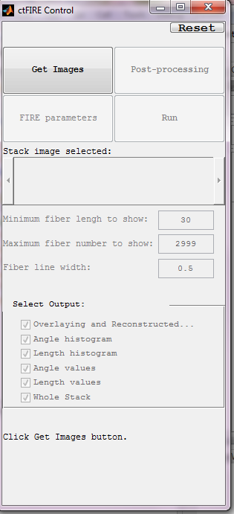

where the following list describes the function of each of the buttons and controls:

**Reset**: rerun the GUI

**Get Images**: open an image, a stack or a folder. Currently the processing of a stack and folder is in development.

**FIRE parameters**: set FIRE parameters.

**Run**: select the output folder, run mode (FIRE, ctFIRE or both) and additional ctFIRE parameters if ctFIRE is chosen to run.

**Post-processing**: after Run, change the output setting to get the desired output

**Stack image selected**: when a stack is opened, move the slide bar to select the slices to run and show the current slice. Currently a stack image can be shown but not analyzed. This feature is under development.

Output of the extracted fibers

**Minimum fiber length to show**: only display fibers which are longer than this value, unit is in pixels, default value is 30.

**Maximum fiber number to show**: maximum number of fibers to display default value is 2999

**Fiber line width**: control the line width of the extracted fibers on the overlaid image, default value is 0.5

**Select Output**: select the desirable output, default is output all

**Overlaying and reconstructed**: overlaid image of the extracted fibers on the original image and the CT reconstruction image

**Angle histogram**: figure of fiber angle histogram

**Length histogram**: figure of fiber length histogram

**Angle values**: save fiber angle value into an Excel file

**Length values**: save fiber length value into an Excel file

**Whole Stack**: analyze all the slices in a stack, this function is in development

**Bottom information label**: indicate what to do or the program status

# Tutorial

## Step 1: open images

Click the Get Images button, the following window is displayed allowing the user to select whether a single image or an entire folder of images is to processed.

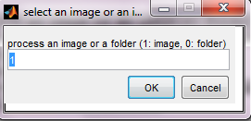

Input a value of 1(default) to process a single image or image stack, enter 0 to analyze all of the images in a specified folder. Click OK. Next, a file selection window opens allowing the user to choose the image or folder to process. In this tutorial, "testimage1.tif" is selected.

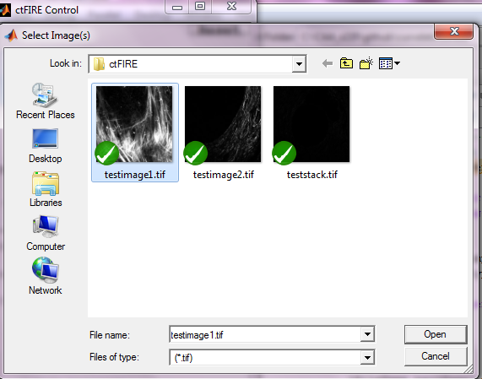

After clicking open, the image is displayed and new controls are enabled on the control panel as shown below.

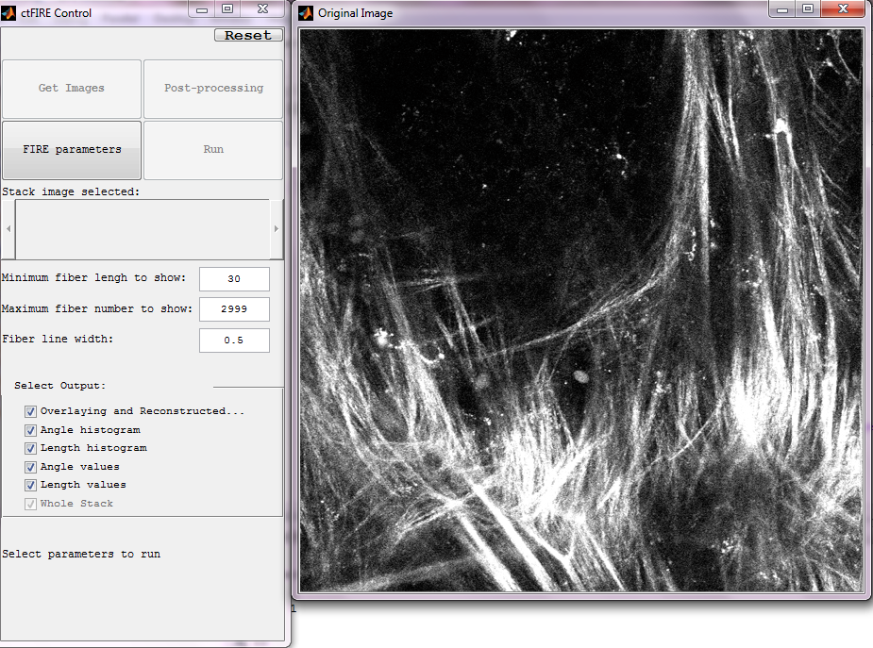

## Step 2: set input and output parameters:

In this tutorial, uncheck the angle and length output as follows and only output the overlaid and reconstructed image, while keep the minimum fiber length, maximum fiber number and fiber line width as default value as in follows:

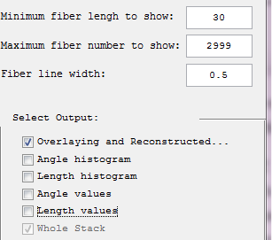

Then set FIRE parameters by clicking the "FIRE parameters" button. The following window is displayed.

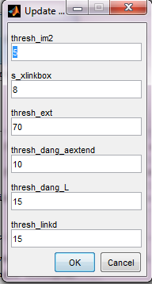

The description of the six parameters is listed below

|  |  |
| --- | --- |
| thresh_im2 | a grey level threshold value used for initially converting the image to a binary image prior to the distance transform |
| s_xlinkbox | side length of square region of pixels in which to check to determine if a pixel is a local max of the distance function |
| thresh_ext | angle similarity required for a fiber to extend to the next point |
| thresh_dang_aextend | maximum dangler angle difference at cross-link |
| thresh_dang_L | dangler length threshold |
| thresh_linkd | distance for linking similarly-oriented fibers |

Change the thresh_im2 to 30 and s_xlinkbox to 5 , click ok. After setting the FIRE parameters , the Run button is enabled.

## Step 3: run

Clicking Run button shows "Select Output Directory". This allows the user to select which folder to place the analysis outputs.

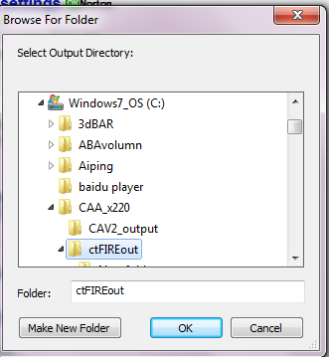

Choose and appropriate folder. In this tutorial the folder called "ctFIREout" is selected. The following window is then displayed allowing the user to select between different analysis options.

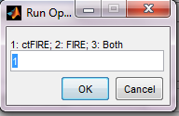

Input 1 to run ctFIRE, 2 to run FIRE, or 3 to run both FIRE and ctFIRE. The default is ctFIRE. Here, Run Option 3 is chosen to run both FIRE and ctFIRE. Finally, a window is displayed allowing the user to select two ctFIRE parameters.

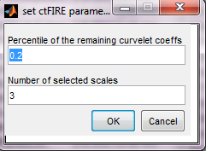

Curvelet transform denoising is performed by transforming to curvelet space, thresholding the curvelets , and then performing the inverse transform using only the selected curvelets. Here, the edit box labeled "Percentile of the remaining curvelet coeffs" is where the user should input the percentage of the curvelet coefficients for calculating the hard threshold applied to each scale in the inverse transformation . The edit box labeled "Number of the selected scales" is to set the scales to reconstruct the image. Specifically, if the total number of scales used by the curvelet transform is N and 3 is the number of selected scales in this edit box, then the actual scales used for reconstruction is scale N-1, N-2 and N-3. In this tutorial, we use the default values and click OK to continue. Then the progress of the curvelet transform and fiber extraction will be listed in the Command Window. The overlaid and reconstructed images will also be displayed.

## Step 4: check the results:

In the output folder : C:\CAA_x220\ctFIREout, 5 output files are shown:

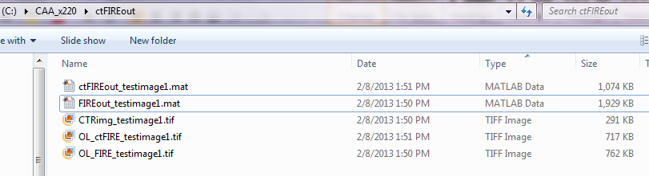

*FIRE output:*

FIREout_ image name.mat: the .mat file for the output by FIRE

OL_FIRE_image name.tif : the .tiff overlaid image of FIRE

*ctFIRE output:*

ctFIREout_ image name.mat: the .mat file for the output by ctFIRE

OL_ctFIRE_image name.tif : the .tiff overlaid image of ctFIRE

CTRimg_image name.tif: the .tiff CT reconstruction image

The three images are shown below:

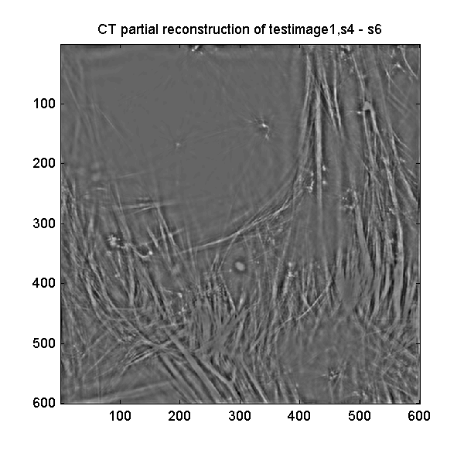

CTRimg_testimage1.tif

OL_ctFIRE_testimage1.tif

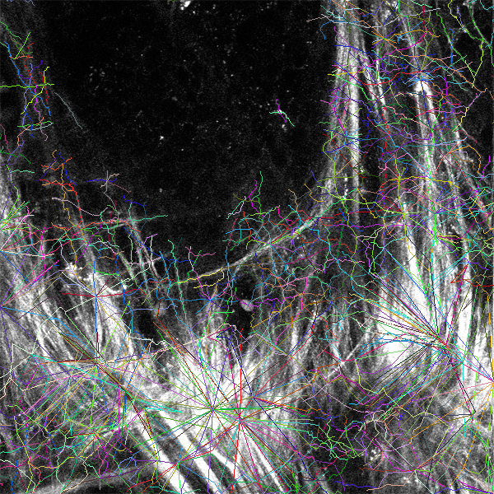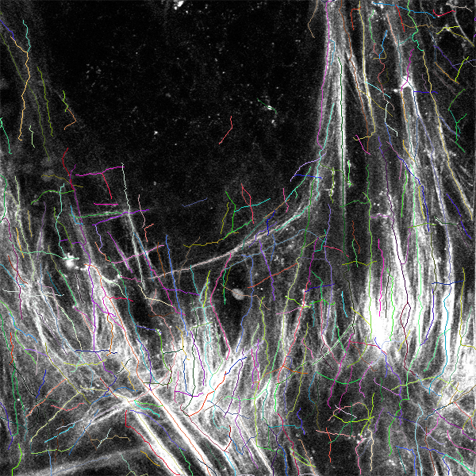

OL_FIRE_testimage1.tif

For this example, the results of ctFIRE looks much better than those of the FIRE.

## Step 5: post-processing

Let's suppose we are satisfied with the overlaid image, now we want to see the angle and length histograms and save the correspond values. In the control panel, the corresponding settings are:

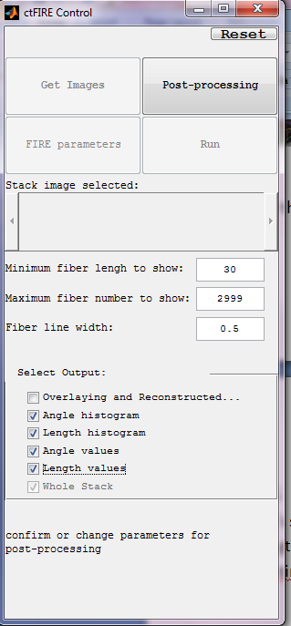

Click Post-processing, then shows:

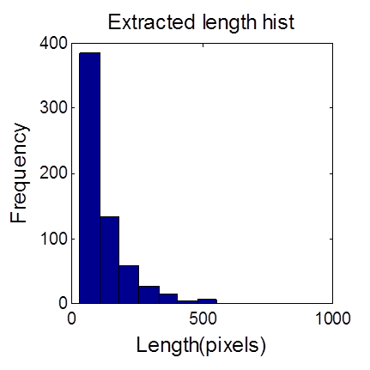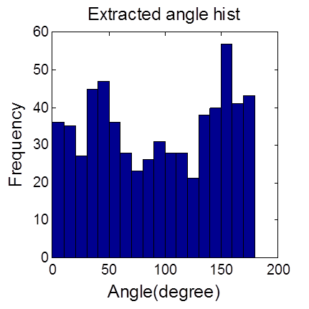

FIRE output

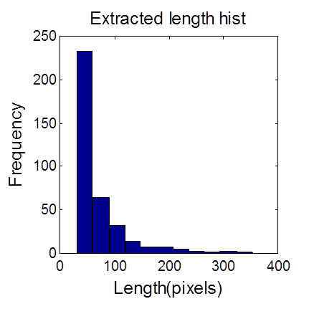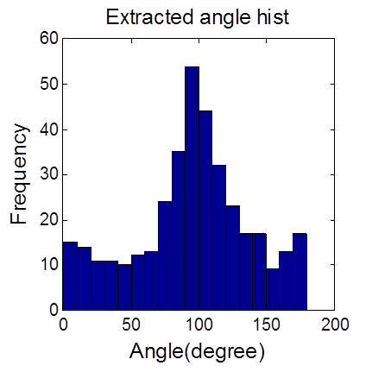

ctFIRE output

The output folder : C:\CAA_x220\ctFIREout, shows 4 additional output files highlighted below which are the angle and length values of both FIRE and ctFIRE:

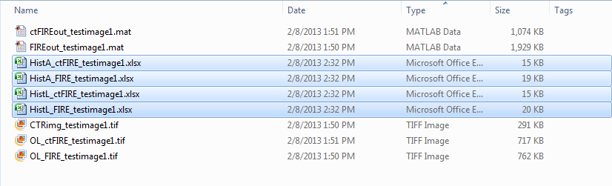

## Step 6: reset

Reset to process a new image or re-process the same image with different parameters.

References:

[1] “curvelet toolbox,” <http://www.curvelet.org/software.html> (19 July 2012).

[2] A. M. Stein, D. A. Vader, L. M. Jawerth, D. A. Weitz, and L. M. Sander, “An algorithm for extracting the network geometry of three-dimensional collagen gels,” *Journal of Microscopy* **232**(3), 463–475 (2008) [doi:10.1111/j.1365-2818.2008.02141.x].